

Data Technician

Name: Alaa Mostafa
Course Date: 16/12/24
Table of contents
Day 1: Task 1 2
Day 2: Task 1 2
Day 2: Task 2 3
Day 2: Task 3 4
Day 3: Task 1 4
Day 3: Task 2 5
Dataset: 5
Step 1: Create a Pivot Table 5
Step 2: Use the SWITCH Function 5
Submission: 6
Day 3: Task 3 6
Day 4: Task 1 7
Course Notes 9
Additional Information 10

Day 1: Task 1

Please complete the below boxes on commons laws and regulations that must be followed when working with customers data, use the below bulleted list to support your answers.

- What is it
- Why is it important
- Provide a real-world example of how you can follow it
- How does it impact working with data
- What could happen if you breached it

Data Protection Act | The Data Protection Act (DPA) is a UK Act of Parliament which passed in 1988. It protects people and lays down rules about how people's personal data can be used by organizations, businesses or the government. As will later be noted, the DPA has been implemented into the GDPR (Experian, n.d.).  The DPA also applies to information or data stored on a computer or an organized paper filling system about people.  The DPA is important because it provides the guidance and implementations for organizations and the government to follow on how to use personal data, including:  - Regulating the processing of personal data,  - Protecting the rights of the person,  - Enabling the Data Protection Authority (The ICO) to enforce rules,  - Holding organizations liable to fines in the event of a breach of the rules.  At the heart of it are eight common sense rules known as the "data protection principles" that all organizations collecting and using personal information are legally required to comply with. The law provides stronger protection for more sensitive information, such as:  - Ethnic backgrounds,  - Political opinions,  - Religious beliefs,  - Health,  - Sexual life/orientation,  - Criminal history (Experian, n.d.).  To provide a real-world example, I have needed to follow the DPA to ensure that research participant's answers were securely stored on my local SSD/hard drive for my dissertation.  Organizations that do not adhere to the rules set out by the DPA risk prosecution by the Information Commissioner's Office (ICO) where fines can reach up to £500,000 and even imprisonment (Experian, n.d.).
GDPR | GDPR stands for General Data Protection Regulation. It is a comprehensive data protection law, providing a fundamental shift in how we approach data privacy and security in the digital age. The law came into effect on 25 May 2018, replacing the outdated Data Protection Act of 1995. It was established to address growing public concerns over data privacy and security in an increasingly digital world. Essentially, GDPR gives the individual more control over their personal data and ensures that organizations securely manage and store European individuals' personal data (GDPR-Advisor, 2024).  To provide a real-world example, I have needed to follow the GDPR when it came to building and securely storing user login information for a website. As per the regulation, my team needed to follow the seven pillars of the GDPR to maintain users' privacy (PHP and MySQL for used as an initial start).  There are Seven Key Pillars for GDPR  - Lawfulness, Fairness & Transparency - Data must be processed legally and fairly, and individuals must know how their data is being used.  - Purpose Limitation - Data should only be collected for a specific purpose and not used for anything else.  - Data Minimization - Only the necessary amount of data should be collected. Less is more!  - Accuracy - Personal data must be accurate and up to date.  - Storage Limitation - Data should not be kept longer than needed. Once it's served its purpose, it should be deleted.  - Integrity & Confidentiality - Data must be kept safe and secure from unauthorized access or breaches.  - Accountability - Organizations must be able to prove they're following these rules and taking data protection seriously. (GDPR-Advisor, 2024).  Assuming I were part of an organization, fines issued by the GDPR would vary:  - up to €10m or 2% of annual global turnover for less serious infringements.  - up to €20m or 4% of annual global turnover for more serious infringement (GDPR-Advisor, 2024).
Freedom of Information Act | The Freedom of Information Act - established in 2000 gives people the right of access to recorded information held by public sector organizations. This includes requests for research data from universities and publicly funded research organizations (UK Data Service, 2021).  Although, there are exceptions to the Act, such as:  - Personal data cannot be requested,  - Information that is accessible by other means, for example, via a website,  - Information intended for future publication,  - Information that is subject to a confidentiality agreement, such as in a signed consent form,  - Sensitive data held under restricted access by a data archive (UK Data Service, 2021).  To provide a real-world example, I would say that I have needed research papers from education/research bodies such as Springer. As per the law, I needed to send requests to access research papers that were recently published.  According to the ICO, there are no financial penalties for failure to provide information on request or for failure to publish information. But the perpetrator could be found in contempt of court for failing to comply with a decision notice.
Computer Misuse Act | The Computer Misuse Act 1990 is the main legislation in the UK designed to handle cases related to computer hacking and others, such as intentionally planted ransomware. Or in other words, individuals that harbour an intent to directly or remotely harm, hack or steal the personal information of others will be issued penalties in accordance with the law (Lister, J., 2025).  I am aware that there is a universal Code of Conduct for red teams and other inter-related cybersecurity disciplines. I shouldn't, for example - in good conscience - misuse WireShark or GoBuster to monitor the web traffic of others, unless with strict permission.  According to Lister, J. (2025), penalties issued under the Computer Misuse Act covers five specific sections. However, to be brief, perpetrators will likely face imprisonment ranging from 2 to 14 years, depending on severity.

References:
The following references will be following Harvard's citation guide "Cite Them Right 12th Edition" (released in 2022)
Experian (n.d) What is the Data Protection Act? [online]. Experian. Available from: https://www.experian.co.uk/business/glossary/data-protection-act/ [Accessed: 18 November, 2025].
GDPR-Advisor (2024) What is GDPR? Understanding GDPR Meaning and Its Impact on Data Protection [online]. GDPR-Advisor. Available from: https://www.gdpradvisor.co.uk/what-is-gdpr [Accessed: 18 November, 2025].
GDPR-Advisor (2023) GDPR Fines and Penalities: What You Need to Know to Avoid Costly Mistakes [online]. GDPR-Advisor. Available from: https://www.gdpradvisor.co.uk/gdpr-fines-and-penalties [Accessed: 18 November, 2025].
ICO (2024) FOI Complaints and ICO enforcement powers [online]. ICO. Available from: https://ico.org.uk/for-organisations/foi/foi-complaints-and-ico-enforcement-powers/ [Accessed: 18 November, 2025].
UK Data Service (2021) Freedom of Information Act [online]. UK Data Service. Available from: https://ukdataservice.ac.uk/learning-hub/research-data-management/data-protection/data-protection-legislation/freedom-of-information-act/ [Accessed: 18 November, 2025].

Day 2: Task 1

Please research and complete the following tasks within the retail-sales_dataset.xlsx document, paste a print screen into the provided boxes below:

- In the sheet ‘retail_sales_dataset’ add all available data between columns A –J into a ‘table’
- Using the ‘sort’ function, sort ‘Age’ to ‘largest to smallest’
- Using the ‘SUM’ function, show me the commission total in cell ‘L10’
- Using the ‘AVERAGE’ function, show me the average commission in cell ‘L11’

Print screen 1 | 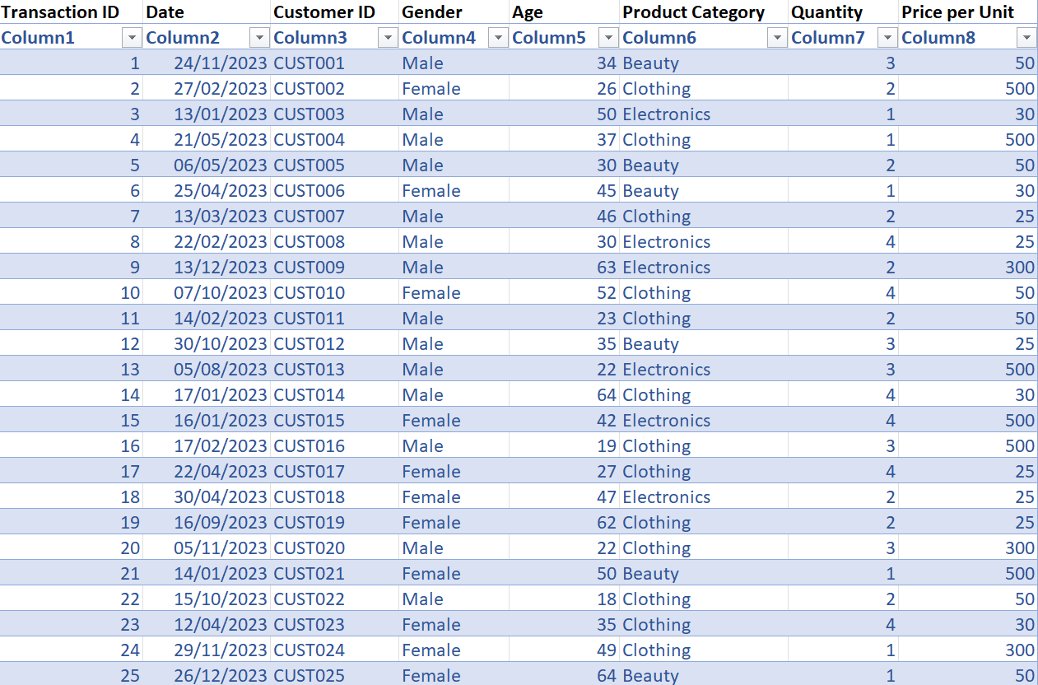
Print screen 2 | 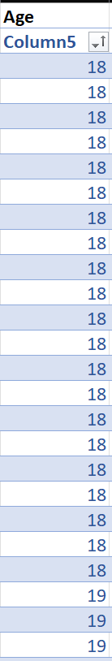
Print screen 3 | 
Print screen 4 | 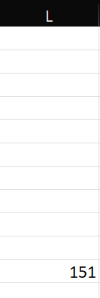

Day 2: Task 2

Please research and complete the following tasks within the retail-sales_dataset.xlsx document, paste print screens into the provided box below:



Print screen 1 | 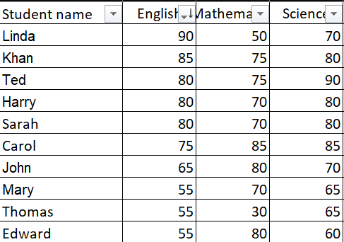

Day 2: Task 3

Using the skills developed today, have some fun with the data set you have imported. Paste your work below and enjoy!

Print screen 1 | 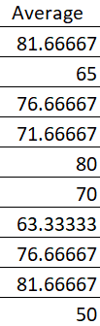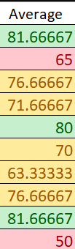

Day 3: Task 1

Please download the dataset ‘Day_3_Task_1_Bike_Sales_Pivot_Lab.xlsx’ and the lab instructions.

Do not worry if you do not complete the lab, just working with data and playing with the pivot table will be good experience.

Please paste your final pivot table below and complete the reflection questions:

Print screen 1 | 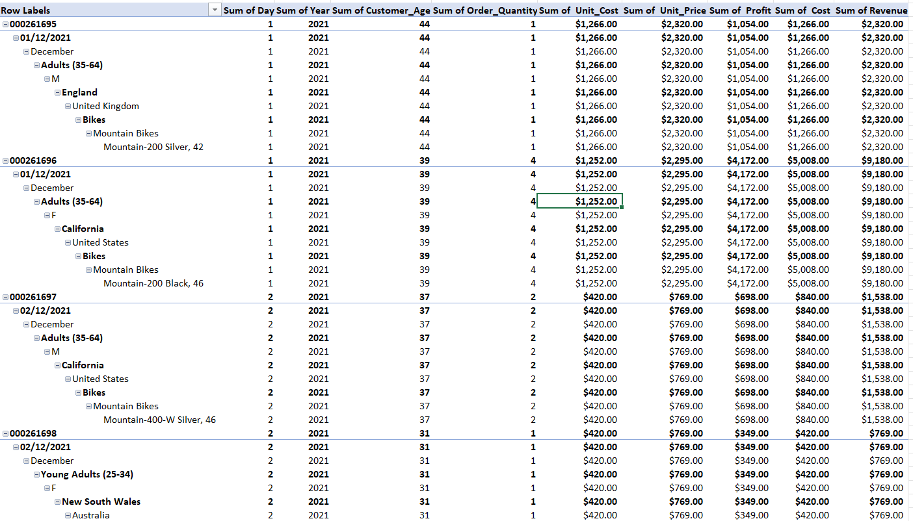
In which markets does Germany have customers? | Mountain Bikes
What country has sales in all markets? | United States
What are the most profitable markets by country, age group, and gender? | Adults (35-64) – 93,496 in the United States  Young Adults (25-34) – 53,962  Youth (<25) – 16,050  F – 94,763  M – 64,224
Any other findings?

Day 3: Task 2

The dataset below tracks the sales performance of different products in various counties in England. Please paste the dataset into a blank Excel workbook. Your task is to:
- Create a Pivot Table to summarise the data by county and product.
- Use the SWITCH function to categorise products based on their sales volume.

Dataset:
County | Product | Sales Volume
Yorkshire | Laptops | 500
Yorkshire | Smartphones | 200
Cornwall | Laptops | 700
Cornwall | Printers | 400
Lancashire | Smartphones | 150
Lancashire | Laptops | 600
Essex | Printers | 800
Essex | Smartphones | 300
Durham | Laptops | 250
Durham | Printers | 300
Greater Manchester | Smartphones | 600
Greater Manchester | Laptops | 400

Step 1: Create a Pivot Table
- Select the dataset (columns A to C).
- Insert a Pivot Table to summarise the data by County in the rows and Products in the columns. Use Sales Volume as the value to be summarised.

Step 2: Use the SWITCH Function
In a new column next to your data, use the SWITCH function to categorise products based on Sales Volume as follows:
  - For sales greater than 600: "High"
  - For sales between 300 and 600: "Medium"
  - For sales less than 300: "Low"
SWITCH Function Example:
=SWITCH(TRUE, C2 > 600, "High", C2 >= 300, "Medium", "Low")
- Apply this formula to each row, and check if the products are categorised correctly.

Submission:
- A completed Pivot Table summarising sales by county and product.
- A new column in the dataset categorising products by sales volume using the SWITCH function.
  - Please paste your completed work below

Print screen 1:  Print Screen 2: | 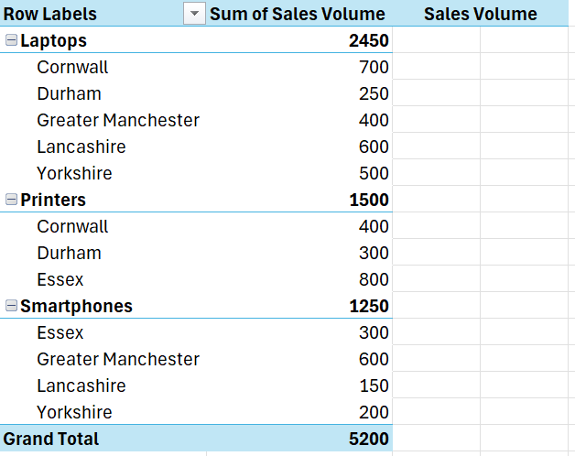  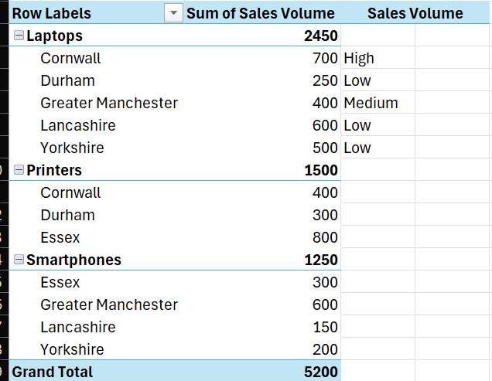

Day 3: Task 3

Please download the dataset ‘Day_3_Task_3_Bike_Sales_Visualisations_Lab.xlsx’ and the the lab instructions. Do not worry if you do not complete the lab, just working with data and playing with the charts will be good experience.

Please paste your results below:

Print screen 1 | 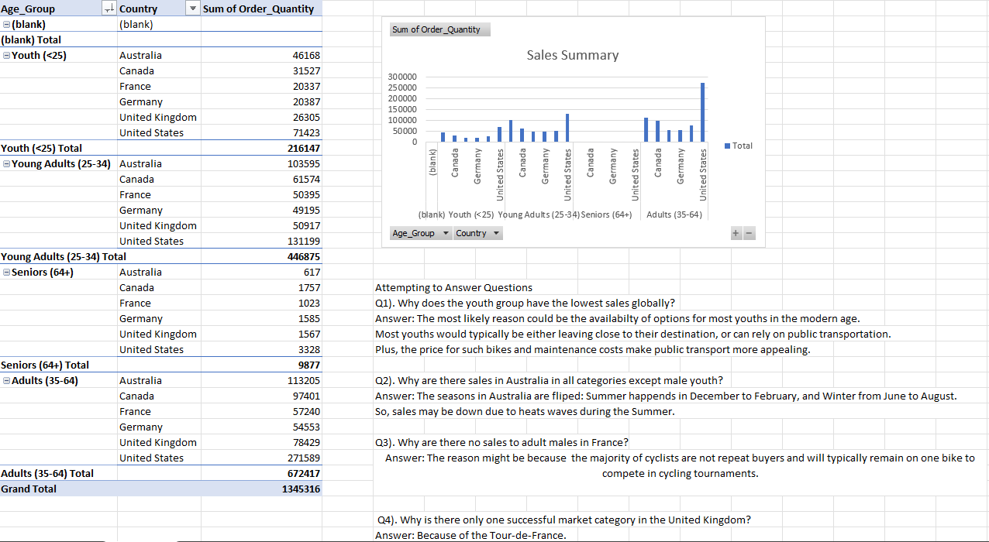

Day 4: Task 1

You have been asked to deliver your analysis findings to the board of directors, with your analysis you have identified that customers are leaving your company at the 12-month point, this is typically when they receive their renewal price.

Conduct research and complete the below questions:

How would you prepare for the delivery? | Understand the Audience:  - Focus on high-level, actionable insights.  - Emphasize company health, growth, profitability, and strategy.  Clarify the Objective:  - Present the churn issue at the 12-month point due to pricing.  - Provide data-backed evidence and propose a solution.  Rehearse:  - Practice the delivery to be concise, clear, and confident.  - Simulate the presentation in front of a colleague/mentor for feedback.  Prepare for Questions:  - Be ready for questions on customer behaviour, and solutions.  Organize Data:  - Ensure data is accurate, relevant, and digestible.  - Use visuals like charts/graphs to support your points.
What tools would you use for the delivery? | Presentation Software:  - PowerPoint or Google Slides for clear, structured delivery.  Data Visualization Tools:  - Tableau or Power BI for interactive dashboards.  Spreadsheet Software:  - Excel or Google Sheets for raw data or modelling (used as backup, not the focus).  Digital Whiteboards:  - Miro or Mural for virtual presentations to explain complex concepts visually.
What is prospecting and why would you complete this before your delivery? | Prospecting refers to:  - Identifying potential solutions and opportunities for improvement.  - Preparing for stakeholder concerns and anticipating their reactions.  Why complete it before delivery?  - Helps you anticipate what board members may be concerned about (e.g., impact on profitability, customer backlash, competitor strategies).  - Allows you to proactively address these concerns during your presentation.
Tell me best practices for public speaking and providing updates to senior leaders | Be Concise:  - Stick to key points. Focus on one clear message for the audience.  Focus on Actionable Insights:  - Present data and solutions that are actionable and relevant to company goals.  Tell a Story:  - Use storytelling to simplify complex issues and make data relatable.  Engage Your Audience:  - Ask questions to involve the board in the decision-making process.  Stay Calm and Confident:  - Manage tough questions with composure, building credibility.  Use Visual Aids:  - Incorporate charts, graphs, and diagrams to make the data clearer and more engaging.
What will you show the board in your delivery? | Key Metrics:  - Customer retention rates, churn rates, and the impact of the 12-month price hike.  Trends and Insights:  - Correlation between price increase and churn, competitor pricing strategies.  Customer Sentiment:  - Feedback from churned customers (e.g., survey responses, NPS scores).  Financial Impact:  - Projected impact of churn on revenue and long-term profitability.  Proposed Solutions:  - Adjusting pricing, introducing loyalty programs, or offering segmented pricing based on tenure.  Benchmarking:  - Industry comparison of churn rates and pricing strategies.
How will you articulate the changes that are needed? | Clarity:  - Present changes simply, using actionable terms (e.g., “gradual price increase after 12 months” or “introduce loyalty discounts”).  Tie to Objectives:  - Link proposed changes to broader company goals (e.g., increasing customer lifetime value, improving retention).  Use Data:  - Show data that supports the need for change (e.g., 35% churn due to price sensitivity).  Risk and Reward:  - Discuss potential risks (short-term margin impact) and rewards (long-term retention and value).  Provide Milestones:  - Set clear next steps and KPIs for monitoring success (e.g., quarterly churn tracking after implementing changes).
Provide a list of online resources and videos that will support your preparation for public speaking | - https://www.youtube.com/watch?v=hYLo4xcBy6c  - https://www.youtube.com/watch?v=CY1Y367KEko  - https://www.youtube.com/watch?v=jizZKNnx9wA
Evaluate tools that provide visualisation.  Tell me what they are.  Tell me what you would choose when delivering your presentation and why | PowerPoint – To allow for simple and effective file transfer.

Course Notes

It is recommended to take notes from the course, use the space below to do so, or use the revision guide shared with the class:

Additional Information

We have included a range of additional links to further resources and information that you may find useful, these can be found within your revision guide.

END OF WORKBOOK

Please check through your work thoroughly before submitting and update the table of contents if required.

Please send your completed work booklet to your trainer.

